**Introduction Chapter 1**

**What is a Client-server model?**

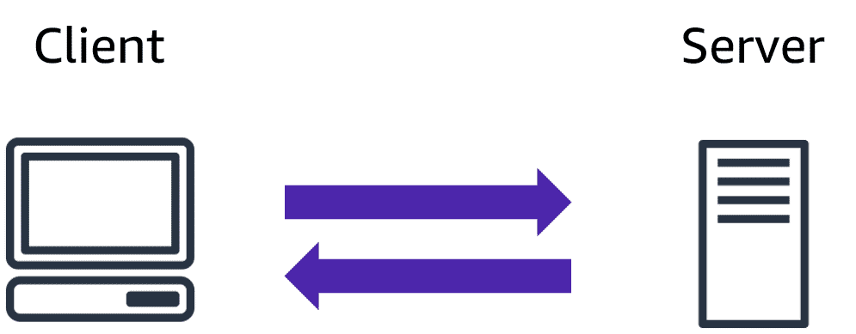

* Client
* In computing a client can be a web browser or desktop application that a person interacts with to make a request to computer servers.
* Server
* A server can be service such as Amazon Elastic Compute Cloud (Amazon EC2), a type of virtual server.

**What is cloud computing?**

* Is the on-demand delivery of IT resources over the internet with pay-as-you-go pricing.

**Deployments models for clouding computing**

1. **Cloud-based Deployment**

* Runs all parts of the cloud in the cloud.
* Migrate existing applications to the cloud.
* Design and build new application in the cloud.

You can build this application in a low-level infrastructure that requires your IT staff to manage them or high-level infrastructure service that reduce management, architecting, scaling requirements of the core infrastructure.

Example -> a company might create an application consisting of virtual servers, databases, and networking components that are fully based in the cloud.

1. **On-premises Deployment**

* Deploy resources by using virtualization and resource management tools.
* Increase resources utilization by using application management and virtualization technologies.

Is also known as a private cloud deployment. In this model, resources are deployed on premises by using virtualization and resource management tools

Example -> you might have applications that run on technology that is fully kept in your on-premises data centre. Though this mode is much like legacy IT infrastructure, its incorporation of application management and virtualization technologies helps to increase resources utilization.

1. **Hybrid Deployment**

* Connect cloud-based resources with legacy IT applications
* Integrate cloud-based resources with legacy IT applications

**A Hybrid Deployment,** cloud-based resources are connected to on premises infrastructure.

Example -> You have legacy application that are better maintained on premises, or government regulations require your business to keep certain records on premises.

**Benefits of cloud computing**

1. **Trade upfront expense for variable expense**

* Instead of having to invest heavily in data centres and servers before you know how you’re going to use them, you can pay only when you consume computing resources, and pay only for how much you consume.

1. **Stop spending money to run and maintain data centres**

* Focus on project that differentiate your business, not the infrastructure.

1. **Stop guessing capacity**

* Eliminate guessing on your infrastructure capacity needs. You can access as much or as little capacity as you need and scale up and scale down as required only a few minutes notice.

1. **Benefits from massive economies of scale**

* Usage from hundreds of thousands of customers is aggregated in the cloud, providers such as AWS can achieve higher economies of scale, which translates into lower pay as-you-go prices

1. **Increase speed and agility**

* New IT resources are only one click away which means that you reduce the time to make those resources available to your developers from weeks to just a minute.

1. **Go global in minutes**

* Easily deploy your application in multiple regions around the world with just few clicks.

**Cloud Computing Models**

1. **Infrastructure as a Service (IaaS)**

* Contains the basic building blocks for cloud IT and typically provides access to networking features, computers (virtual or on dedicated hardware), and data storage.
* The user manages things like operating system, apps and middleware while the provider takes care of hardware, networking, hard drives, data storage, and servers

1. **Platform as a Service (Paas)**

* Removes the need for your organization to manage the underlying infrastructure (usually hardware and operating systems)
* allows you to focus on the deployment and management of your application
* You don’t need to worry more about resources procurement, capacity planning, software maintenance, patching, or any of the other undifferentiated heavy lifting involved in running your application.

1. **Software as a Service (SaaS)**

* Provides you with a completed product that is run and managed by the service provider. You don’t not have to think about how the service is maintained or how the underlying infrastructure is managed, you only need to think how you will use that piece of software. E.g., web-based email.